Shared Resources Setup Document

**Project 2**

**Last Updated: September 24, 2025**

**Contents**

1. Overview 2
2. Directory Structure 2
   1. Explanation 2
   2. Directory Structure Visualization 2
3. Users and Groups 3
   1. Users 3
   2. Groups 3
   3. Commands Used 3
   4. User and Group Verification Visualization 3
4. Ownership and Permissions 3
   1. Private Directory 3
      1. Commands Used 3
   2. Public Directory 4
      1. Commands Used 4
   3. Permissions Setup Visualization 4
5. File Population 4
   1. Commands Used 4
   2. File Permissions Visualization 4
6. Backup and Sync 5
   1. Manual Backup 5
   2. Automated Backup (Cron) 5
   3. Cron Job Setup Visualization 5
7. Verification and Testing 5
   1. Access Testing 5
   2. Verification Commands 5
   3. Access Testing Visualization 6

1

# Overview

This document outlines the setup process for the shared_resources directory structure for Project 2. It covers user and group management, permissions, file population, backup configuration, and verification steps. Visual demonstrations are referenced where applicable.

# Directory Structure

The directory structure for shared_resources is as follows:

shared_resources/

├── private

│ ├── file1.txt

│ ├── file2.txt

│ └── file3.txt

├── public

│ ├── file1.txt

│ ├── file2.txt

│ └── file3.txt

├── backup_for_private

│ ├── file1.txt

│ ├── file2.txt

│ └── file3.txt

├── backup_for_public

│ ├── file1.txt

│ ├── file2.txt

│ └── file3.txt

## Explanation

* private: Contains restricted files accessible only by the owner and project2grp

group members.

* public: Contains files readable and traversable by everyone, with write permissions restricted to the owner.
* Files in both directories are project-related documents or scripts.

## Directory Structure Visualization

[Placeholder for Image: Directory Structure]

# Users and Groups

## Users

* employee1: Member of project2grp.
* employee2: Not a member of project2grp.

## Groups

* project2grp: Controls access to the private directory.

## Commands Used

Listing 1: User and group creation commands

# Create users with home directories

sudo useradd -m -d /home/shared_resources/employee1 employee1 sudo useradd -m -d /home/shared_resources/employee2 employee2

# Create groups

sudo groupadd project2grp

# Add users to groups

sudo usermod -aG project2grp employee1

1

2

3

4

5

6

7

8

9

## User and Group Verification Visualization

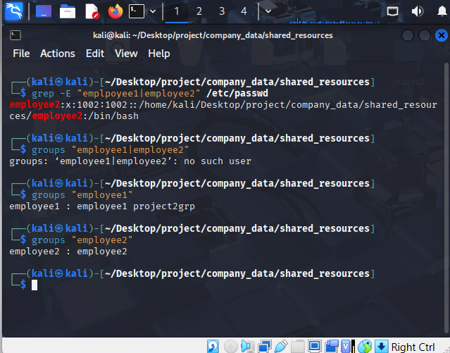

# Ownership and Permissions

## Private Directory

* **Owner**: Full access (rwx).
* **Group** (project2grp): Read and execute (r-x).
* **Others**: No access (—).

### Commands Used

Listing 2: Private directory permissions

sudo chown kali:project2grp shared_resources/private sudo chmod 750 shared_resources/private

1

2

## Public Directory

* **Owner**: Full access (rwx).
* **Group**: Read and execute (r-x).
* **Others**: Read and execute (r-x).
* **Sticky Bit**: Prevents file deletion by non-owners.
* **Setgid**: Ensures new files inherit the group.

### Commands Used

Listing 3: Public directory permissions

sudo chown kali:project2grp shared_resources/public

sudo chmod 2775 shared_resources/public # setgid (2), owner (rwx), group (rwx), others (r-x)

sudo chmod +t shared_resources/public # sticky bit

1

2

3

## Permissions Setup Visualization

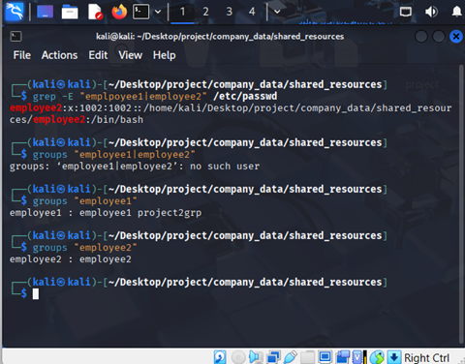

# File Population

* private Directory: Contains file1.txt, file2.txt, file3.txt.
* public Directory: Contains file1.txt, file2.txt, file3.txt.

## Commands Used

Listing 4: File creation and permissions

setfacl -m u::rwx,g::r-x,o::r-x ./public/

setfacl -m u::rwx,g::rw-,o::--- ./private/ # Create files

touch shared_resources/private/file1.txt shared_resources/private/ file2.txt shared_resources/private/file3.txt

touch shared_resources/public/file1.txt shared_resources/public/ file2.txt shared_resources/public/file3.txt

1

2

3

4

5

## File Permissions Visualization

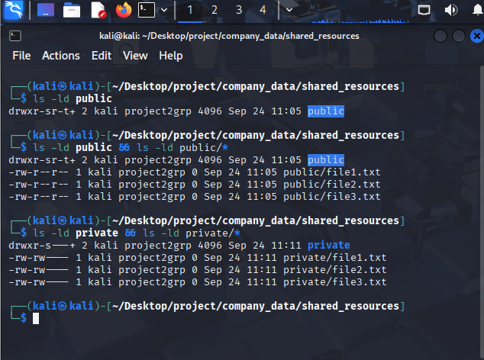

# Backup and Sync

## Manual Backup

Listing 5: Manual backup commands

rsync -av shared_resources/public /home/kali/Desktop/project/ company_data/shared_resources/backup_for_public

rsync -av shared_resources/private /home/kali/Desktop/project/ company_data/shared_resources/backup_for_private

1

2

## Automated Backup (Cron)

* **Schedule**: Daily at 2 AM.
* **Command**:

Listing 6: Cron job for automated backup

0 2 * * * rsync -av /home/kali/Desktop/project/company_data/ shared_resources/public /home/kali/Desktop/project/company_data/ shared_resources/backup_for_public && rsync -av /home/kali/ Desktop/project/company_data/shared_resources/private /home/kali/ Desktop/project/company_data/shared_resources/backup_for_private

1

## Cron Job Setup Visualization

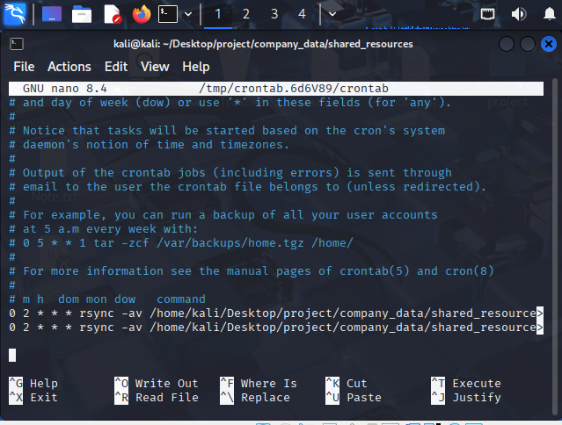

# Verification and Testing

## Access Testing

* private Directory: Only the owner and project2grp members can read-

/execute files.

* public Directory: Everyone can read/traverse; only the owner can write.

## Verification Commands

Listing 7: Verification commands

# List directory and file permissions

ls -ld shared_resources/private shared_resources/public ls -l shared_resources/private

ls -l shared_resources/public

# Verify user group membership groups employee1

groups employee2

1

2

3

4

5

6

7

8

## Access Testing Visualization

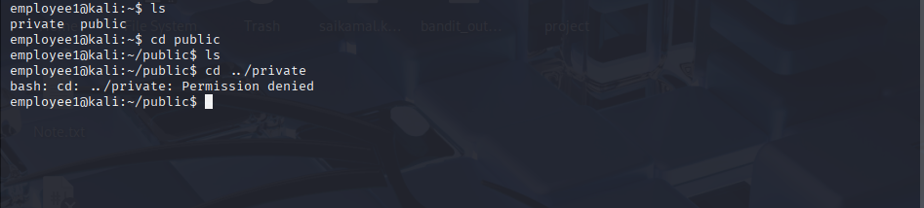

**8. Overall process image**

